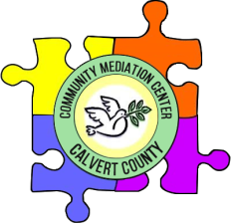
Community Mediation Center of Calvert
Phone: 443.295.7456
www.calvert-mediation.org

P.O. Box 1842
Prince Frederick, MD 20678
#73087

Building community, peace by peace

December 8, 2022

Dear Friends,

As 2022 comes to an end, I want to express my gratitude for CMCC’s team of dedicated staff and volunteers, community partners, and supporters. It’s been a busy year of mediations, community conversations, restorative practices, and conflict resolution training. We could not have done it without your support. I hope that you will consider supporting CMCC into 2023 so that we can continue supporting peaceful solutions to conflicts in our community.

CMCC provides mediation for anyone who needs a safe, supportive space to have a conversation. Families experiencing divorce, landlord/tenant conflicts, individuals reentering the community from incarceration, civil court cases, neighbor conflicts, school issues, and eldercare disputes are just some of the issues we have mediated this year. There is no cost and no referral needed to access our mediation services. Our trained, volunteer mediators are available during the day, the evening, and even on weekends to support our community in preventing and resolving conflict and repairing relationships.

In addition to voluntary, confidential, impartial, and no cost mediation, CMCC provides many other services to our Calvert community, including:

- Community Conferencing/Restorative Justice, which provides an alternative to traditional punitive disciplinary and criminal justice frameworks and focuses on accountability, restitution, and reintegration.
- The Big Conversation on Dismantling Racism and Privilege, which has brought together individuals, organizations, and churches committed to social justice work. This year’s topic was trauma.
- Conflict Coaching, which provides one-on-one sessions with a mediator to assist individuals in dealing with conflicts in their lives.
- Triple P Parenting Training, which includes Family Transitions for divorcing parents and Discussion Groups for parenting issues.
- Conflict Resolution Education for Recovery, which teaches conflict resolution skills to individuals in recovery from substance use disorders to support their sobriety and repair relationships.
- Classroom Peace Circles, which help create a class community and foster better relationships in school.
- Conflict Resolution Skills Training, which includes Peer Mediation and Basic Mediation for new mediators.

Our services are partially funded by a grant from the Mediation and Conflict Resolution Office (MACRO), but we rely on donations for much of our work. If the work of peaceful conflict resolution is important to you, we hope you will support CMCC. We appreciate every donation, no matter the size. If you would like more information, please visit our website at www.calvert-mediation.org to learn more about what we do. Thank you.

Wishing you a happy and peaceful 2023,
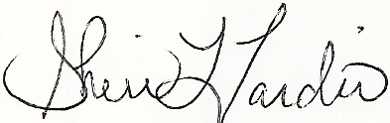

Sheri L. Tardio, PhD
Executive Director
---------------------------------------------------------------------------------------------------------------------------------------------------------
YES, I will support the peacemaking work of the Community Mediation Center of Calvert! Enclosed is my donation.
- $25.00, which will a workbook for Conflict Resolution for Recovery participant
- $50.00, which will provide materials for youth conflict resolution training activities
- $75.00, which will cover the cost of an advanced mediation training course for a volunteer
- $100.00, which will cover the cost of providing 2 peace circles for a classroom
- $200.00, which will cover the cost of an introductory conflict resolution skills training for an agency
- Other:________________________

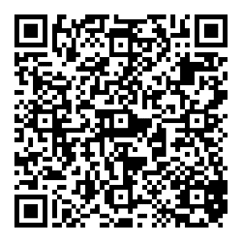
You can also donate online at www.calvert-mediation.org
or scan the QR code!
Thank you so much for your support!

